* Create an account in docker hub and create a repository in that
* And then login to the account from CLI as below

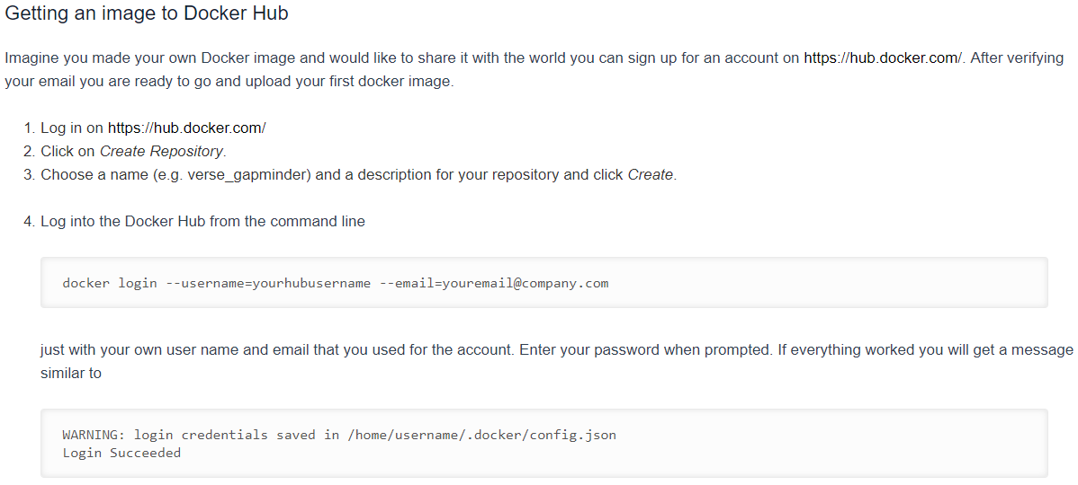

* Tag the image to the repository as below

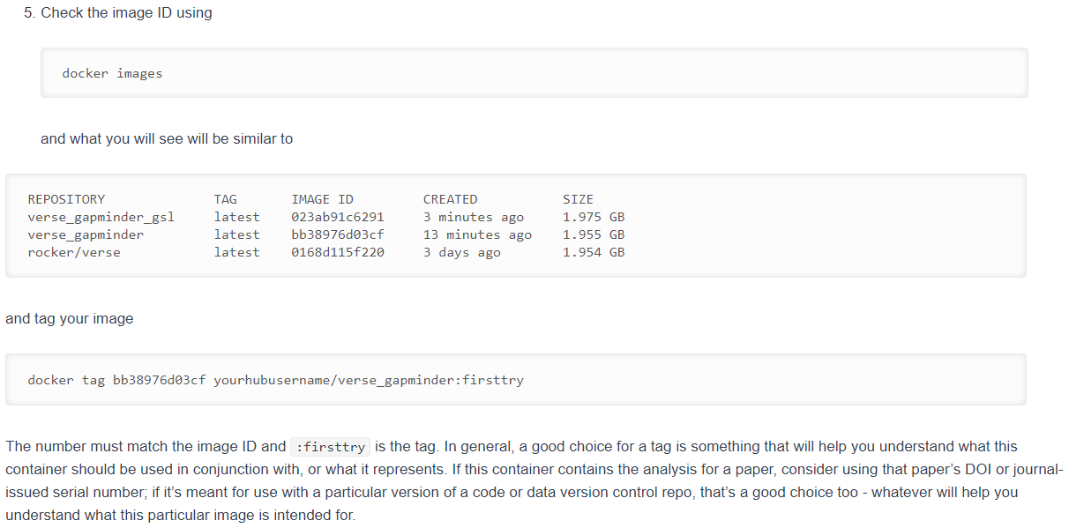

* Tag the image as “userid/imagename” in locally
* Now push the image to registry with the name we created above
* Push the image to our repository as below

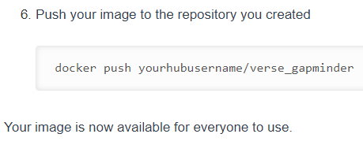

* If we push the image with new tags. We can see them in registry as below



**Saving & loading images:**

